If you are looking for A great way to celebrate the Season of Advent, please join us at our

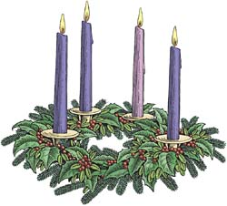
ADVENT WREATH WORKSHOP
Sunday, November 25, 2018
St. Charles School Cafeteria, 9:30 – 11:00 a.m.

Advent is a great way to keep focused on preparing for the coming of the Christ Child. Each new week of Advent begins at Mass with the lighting of a new candle on the parish Advent Wreath. Our parish family is connected to our personal family when we light our own Advent Wreath at home.
Please join us as we make live Advent Wreaths, bless our wreaths, and have breakfast together! Provided will be a presoaked oasis wreath form with tray, fresh assorted greens, candle set, Advent prayer booklet and breakfast.
All you need to bring is garden sheers.
Come as a family, or invite whoever you want to invite, singles welcome.

If you go to the 10:45, you can come and make a wreath before mass

REGISTRATION IS REQUIRED NO LATER THAN
MONDAY, NOVEMBER 19TH

How to register? Fill out the form below, include the $20 fee and return it to the Parish Office, put it in an envelope and put it in the collection basket,
or drop it off at the school office. Checks should be made out to St. Charles Parish.
We will confirm that we have received your registration by e-mail.
Donuts, Bagels, Hot Beverages, Milk and Juice included.

If you have any questions, please call 434-9272

$20.00 fee must accompany registration for this event.

-----------------------------------------------------------------------------------------------------------------
Please fill out the entire form.

Name_______________________________________________________

Number Attending___________

Phone__________________________

Email _______________________________________________________

Number of wreaths___________ @ $20.00 = Total__________________

Included in the fee: Breakfast, Wreath, Candles, and Advent Reflection Booklet Please bring a pair of garden sheers. Due Date: November 19th

